NAME: SARIYALA HRITIK GOVIND

ROLL NO : 35

SUBJECT: CLOUD COMPUTING

TOPIC : CLOUD TASKS

* **WHAT IS Cloud Tasks**

Cloud tasks is a fully managed service by Google Cloud that allows developers to manage the execution of distributed tasks on behalf of an application. It enables developers to offload and execute tasks asynchronously, decoupling their main application logic from potentially time-consuming processes. Cloud Tasks is often used in scenarios where background processing, task scheduling, and asynchronous workflows are needed.

* **Key Features of Cloud Tasks:**
* **Asynchronous Execution:** Tasks are executed independently of the main application flow, allowing the application to remain responsive.
* **Automatic Scaling:** Cloud Tasks automatically scales the execution of tasks based on demand, ensuring efficient use of resources.
* **Retry and Failure Management:** Cloud Tasks provides built-in mechanisms to retry failed tasks and manage errors.
* **Rate Limiting and Task Scheduling:** You can control the rate at which tasks are executed and schedule tasks to run at specific times.

**Types of Cloud Tasks:**

1. **Pull Tasks:**
   * These tasks are added to a queue but are not automatically executed. Instead, a worker application pulls tasks from the queue when it is ready to process them.
   * This type of task gives more control to the developer over the execution timing and concurrency.
2. **Push Tasks:**
   * These tasks are automatically delivered to an endpoint, such as an HTTP target (usually an App Engine service or an arbitrary URL).
   * Cloud Tasks manages the delivery and retries in case of failures.
   * Push tasks are suitable for scenarios where tasks need to be executed as soon as possible after being enqueued.

* **Diagram Representation:**

I'll describe a diagram that illustrates the architecture and flow of Cloud Tasks: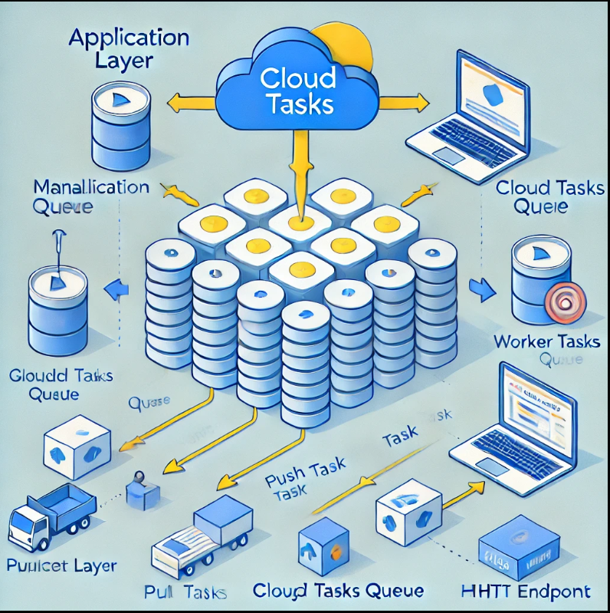

1. **Application Layer:**
   * The application creates tasks and enqueues them in a Cloud Task queue.
   * The tasks can be either push or pull type depending on the configuration.
2. **Cloud Tasks Queue:**
   * This is the managed queue where tasks are stored until they are ready to be processed.
   * For push tasks, the queue automatically pushes tasks to the designated HTTP endpoint.
   * For pull tasks, the worker application pulls tasks from the queue as needed.
3. **Worker/Target Layer:**
   * **For Push Tasks:** The tasks are automatically sent to a target endpoint, such as a REST API, where they are processed.
   * **For Pull Tasks:** The worker application pulls tasks, processes them, and can acknowledge their completion.
4. **Optional Retry and Failure Management:**
   * If a task fails, Cloud Tasks automatically retries it based on a defined retry policy.

This process decouples the application logic from task execution, allowing better scalability and fault tolerance.